

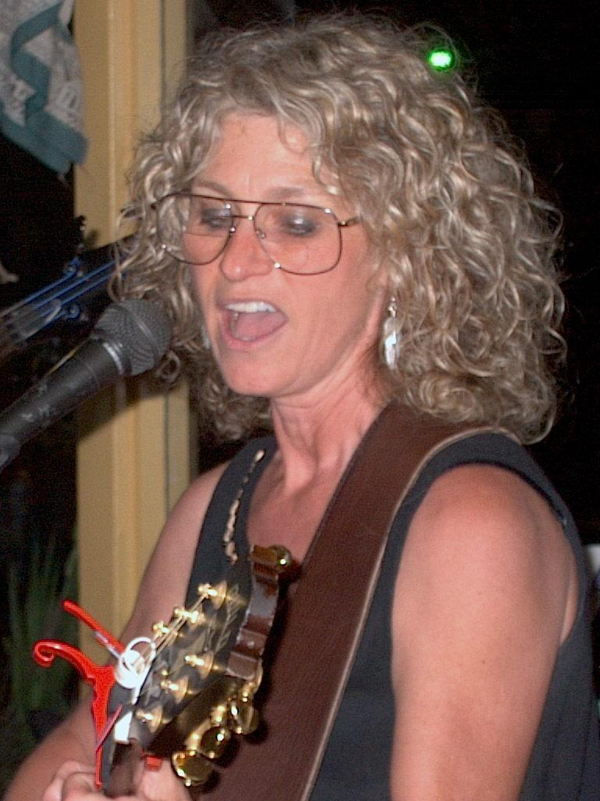

TABLOID COFFEE

Santee, California

Friday, SEPTEMBER 10, 2004
7:00 – 10:00 PM

Patty Hall is a singer-songwriter and 4^{th-}generation Californian who has returned to her home state after 25 years in Music City, USA. Also a folklorist and children’s book author, Patty merges her music with her authorly and scholarly pursuits, for a fusion of spunky originals, old-timey banjo tunes, funky girl blues, upbeat kids’ songs, and topical ballads—spiked with folkloric commentary and good humor. Join Patty, along with song stylist GREG CAMPBELL and other musical guests, for a night of music and fun at the TABLOID!

Patty will also be signing her books about Johnny Gruelle & Raggedy Ann & Andy.

TABLOID COFFEE / 9225-27 Carlton Hills Blvd #27 (near 7-11 & Mission Federal Credit Union) / Santee, CA / 619-562-1240

VISIT PATTY at http://www.pattyhall.com

